

# Team 24 – Sprint 1 Testing Document

Sakshi Choudhary, Giorgi Khmaladze, Nick Litman, Mihir Somani, Conley Utz

# User Story #14

**Test 1: Testing if the password is hashed when a new user is registering.**

Purpose: To meet the acceptance criteria the password that a user chooses must be stored as a hash.

Steps:

1. The user navigates to the sign-up page. 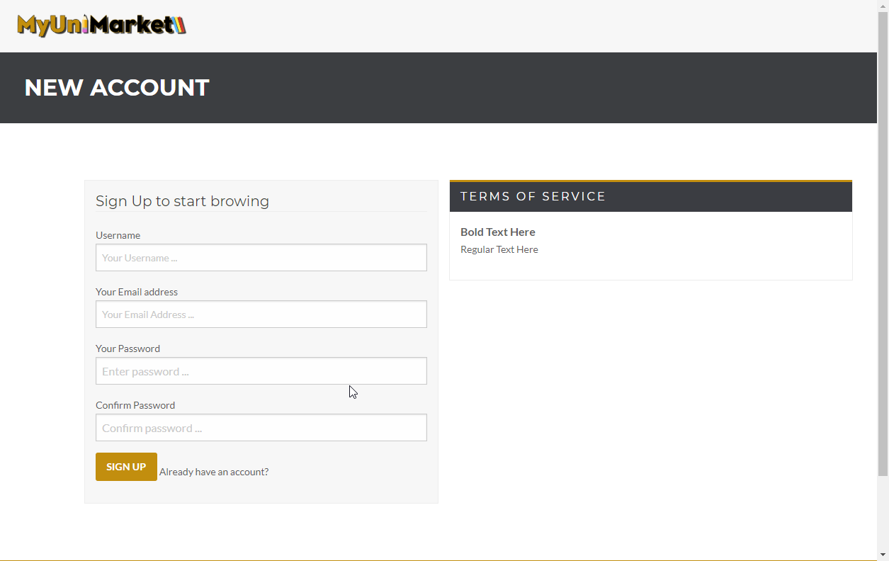
2. The user enters their details in the given fields. (Testing password is 123)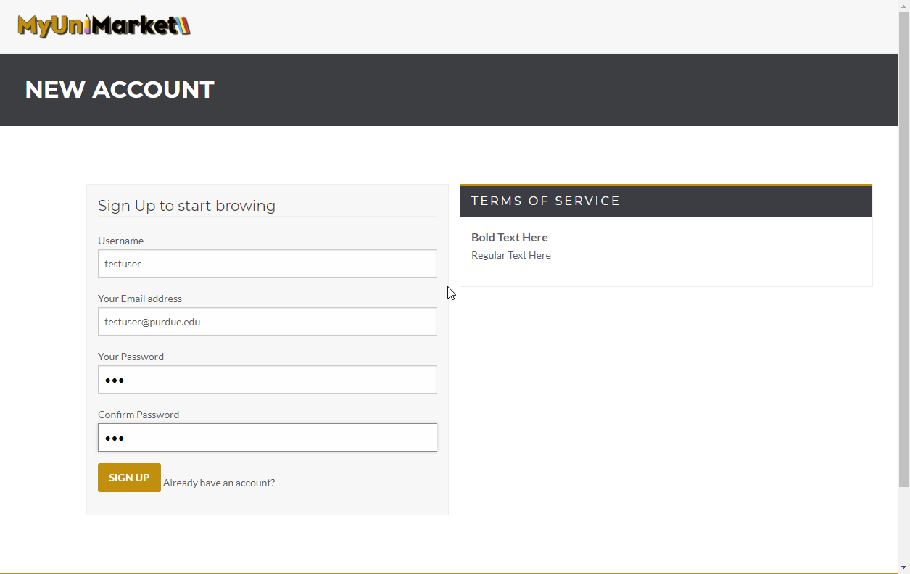
3. Looking at the database, a user with the email and username given above does not exist. 
4. The user clicks “SIGN UP” 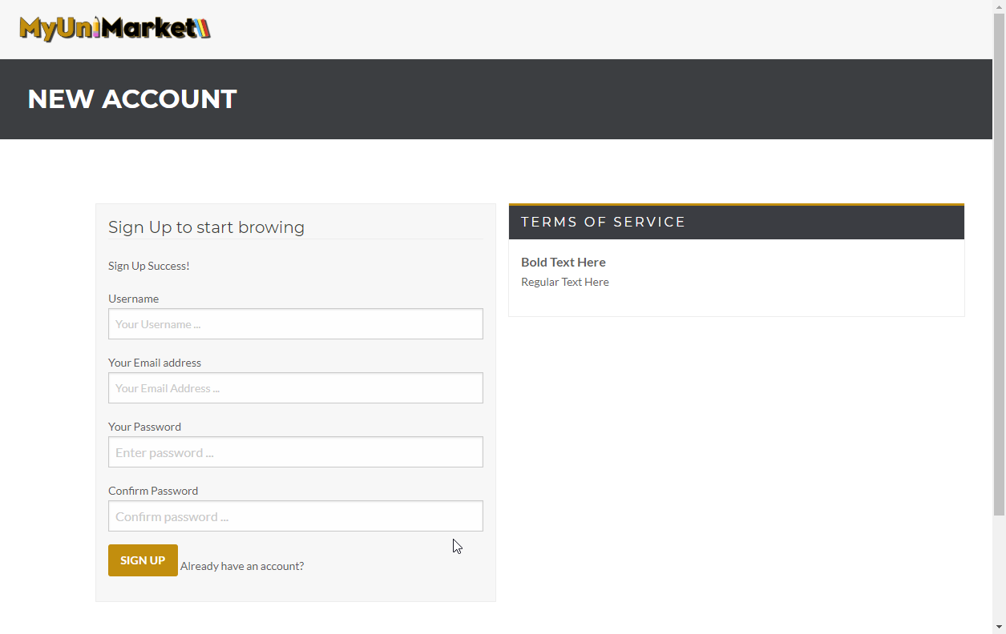
5. The user is added to the database with a hashed password. 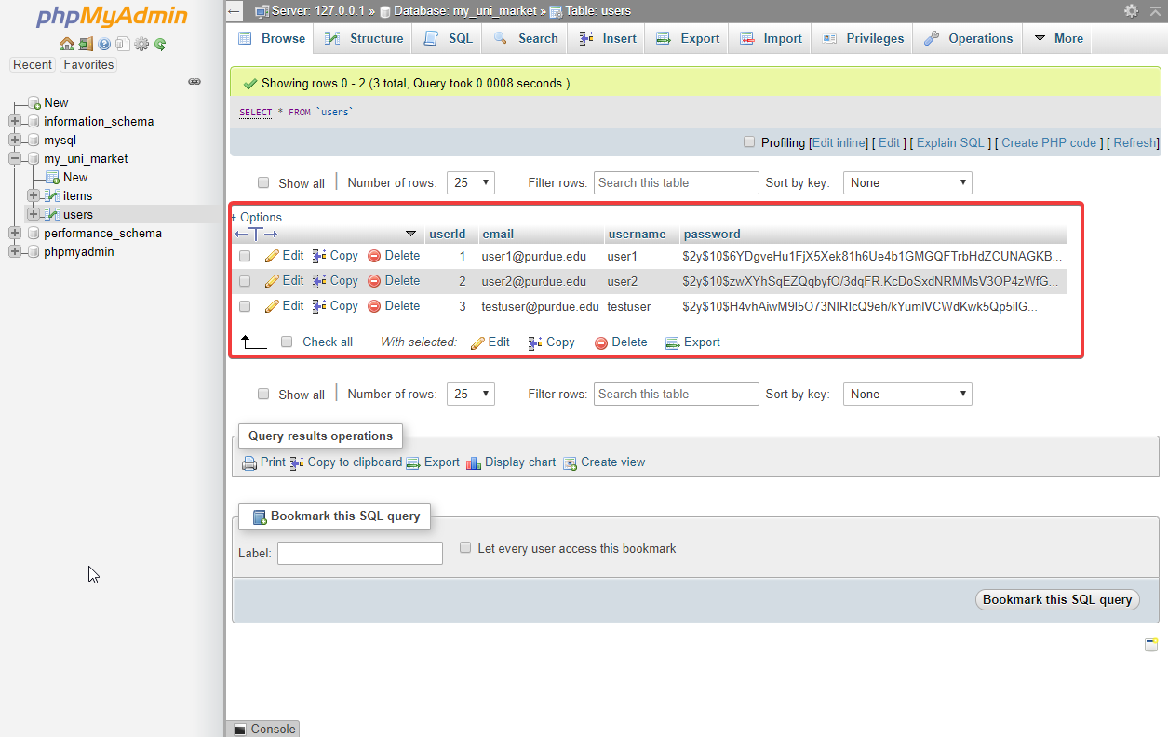

Expected Result: Any password a user decides to choose must be hashed and stored in a hash form for security.

Test Result: **PASSED**